Lab 11a Viewing Certs on your PC

Chrome Certificates

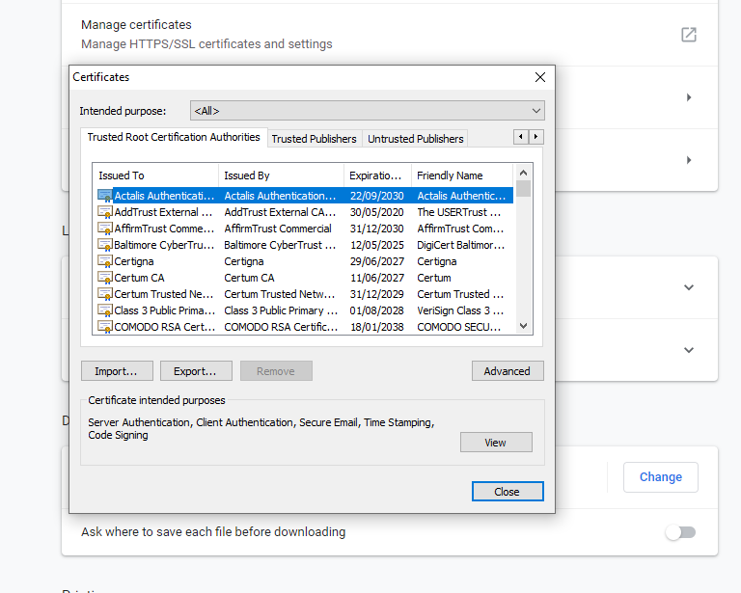

Internet Explorere

Open Internet Explorer → Open Internet Options → Content → Certificates.

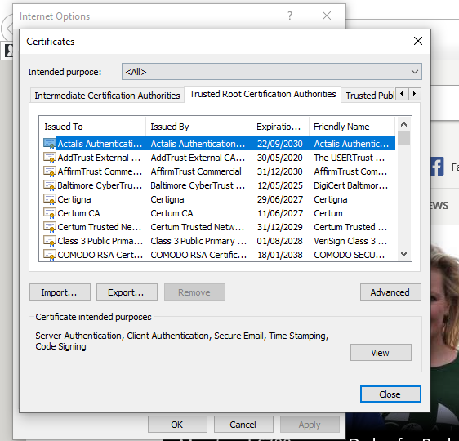

Certificates on Tor 